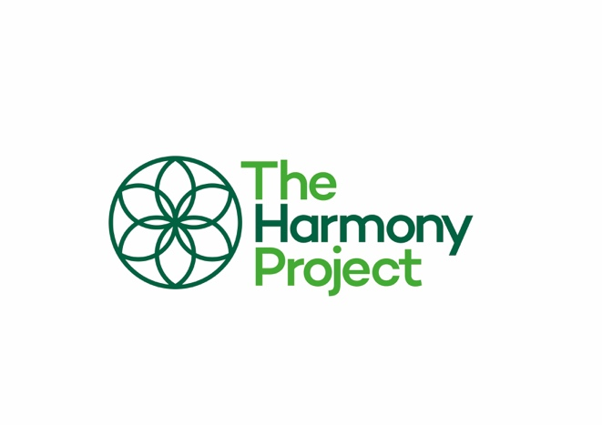
Half-termly planning overview

Enquiry question:

Nature’s principle of Harmony:

Great Work:

Partners in learning:

Sustainability action:
Weekly Questions

 | Week 1 | Week 2 | Week 3 | Week 4 | Week 5
WEEKLY QUESTION
ENGLISH
GRAMMAR & PUNCTUATION
MATHS APPLICATION
SCIENCE
HISTORY/
GEOGRAPHY
ART/DT
COMPUTING
PE
MUSIC
PSHE
OUTDOOR LEARNING

